# **Introduction**

Building websites generally involve people with specific skill set. Using automated systems, we can reduce the work load for Web Developers and at the same time this process can be taken a step further to create bots which can build websites for the naïve users with minimum Web Development experience. The Website Designing Bot(WDB) will use this concept and will conversate with the users to get their preferences related to designing their websites. The bot will work on various principles which are explained. The field of study that focuses on the interactions between human language and computers is called NLP. It sits at the intersection of computer science, A.I, and computational linguistics. The users need to interact with the WDB using natural language like English which will be processed and used to identify the intent of the user, or what the user means. Using this we can determine what kind of website the user requires and thus identify the perfect templates for the same. Continuing this format, we can determine all the add-ons the user desires that will make a fully-functional website. Apart from NLP, our project uses the generalized concept of Agent in A.I. to determine the template which it needs to search based on the processing of language of the user and then display them for the user to choose.

## **1.1 Motivation**

The Internet is everything in today’s world: the tabloid, the newspaper, advertisement agency, etc. Presence on the Internet defines our connection to the outside social world whether it is using Facebook or our own websites. While the former is very easy to get onto, the latter might require some skills and knowledge in order to be established. This is where the problem lies as not everybody is going to be an expert in Web Development or even know the basic concepts behind designing a website. Other reason could be our limited time. Unlike Blogger or WordSpace, which still requires us to have some idea about implementation, the WDB can build all the basic blocks of the website just by conversing with the user. User can have their requirements at the back of their minds and then choose from the wide variety of options present to customize their website to the fullest extent.

## **1.2 Existing System**

1.2.1 Heek

Heek is a conversational website builder. It helps individuals create their website by chatting over text and answering questions. The platform has a conversational interface where chat bots asks questions about the users, the type of business they have, and their sites. Heek is easy-to-use. It also offers a variety of templates where users can choose for their websites. It was developed by Nicholas Fayon who founded Heek at Paris, Ile-de-France, France in the year 2015. They also offer hosting and a custom domain name for a modest monthly fee or subscription.

1.2.2 Wix ADI

The Wix ADI uses A.I. to design websites for small businesses and personal websites like Heek. Wix is a cloud-based web development platform created by Nitzan Achsaf. Wix ADI was unveiled in June 2016. Wix ADI is the world's first technology platform that combines website design and content creation with artificial intelligence to enable complete websites to be created. To get started, users are asked a series of questions. The first question is what category your business falls into. Then, users are asked if their business has an existing online presence, so the tool can find information automatically and pull it in. Finally, ADI asks about a user's design preferences and what he or she wants the site to look and feel like. Then, after a few minutes, the user is presented with a custom homepage.

## **1.3 Applications**

1.3.1 Building personal websites from scratch in matter of minutes -

Social presence is important and what better way to accomplish this is by using your own website, apart from Facebook or Twitter pages. Unlike Facebook, personal websites are customizable to the core and reflects more of ourselves.

1.3.2 Establishing small scale business(SMB) -

The major chunk of motivation for the project comes from this domain. A small scale business requires the boost a website can provide to flourish. Internet is accessible to everyone and it is the best form of advertisement possible in today’s time. Services like retail, information about products and services provided can be highlighted and make it easier for people to get to know your company or business.

1.3.3 Advertising -

Anyone can advertise themselves or their companies on the world’s largest platform. Meeting new clients, connecting with new business partners becomes much easier.

1.3.4 Connecting with Clients/Partners –

Advertising your website along with contact details and services like email enquiry have made this means of advertisement most convenient and helpful. You can integrate such features in your website to give people better way to connect with yourself and your company.

## **1.4 Organization of Report**

The report is divided into 8 chapters. Each chapter has different sections along with its explanations.

Chapter 1 : Introduction

* This part introduces to the concept of the WDB. The motivation to develop this project and previous work done in this domain are listed.
* Different applications of our system are also shown.

Chapter 2 : Literature Survey

* A literature survey is a text of a scholarly paper, which includes the current knowledge including substantive findings, as well as theoretical and methodological contributions to a particular topic
* The findings of different papers based on/related to Website Designer Bot are summarized in this chapter.

Chapter 3: Requirement Analysis

* Requirements analysis, also called requirements engineering, is the process of determining user expectations for a new or modified product.
* The functional and non-functional requirements for the development of the project are listed.

Chapter 4 : Project Design

* This part includes overview of methods that can be used to design and implement the system.

Chapter 5 : Technologies Used

* The tools and programming language useful for implementation of the project are specified in this chapter

Chapter 6 : Conclusion

* The concluding remarks on the project are described here.

Chapter 7 : References

* Different sources and papers used for the development of the project are cited here.

# **Literature Survey**

As per discussed in in the Existing System section, we have system’s like Conversational Designer Bots and Development of website using ADI. In the ADI system it possesses limited capabilities like lower level of interaction with the users making the process less dynamic in nature. Also, the NLP utilization is not much effective. Since, the user may feel like they are talking to an automated system, instead they should feel that they are conversating with a human.

# 2.1 “Seven golden rules for World Wide Web page design.” Mary L. R. Jones.

This paper summarises the factors that potential WWW site owns should think about when planning and designing their WWW pages in order to make sure they achieve the benefits they are hoping for. Technology, standards and user expectations in this area are changing fast. This paper does not assume any particular technology but instead focuses on drivers which seem likely to remain constant, however much the technology changes.

2.2 “AI BASED CHATBOT”, Nikita Hatwar, Ashwini Patil, Diksha Gondane

Chatbots are software agents that interact with the user in a conversation. The main goal of their creation was to resemble a human being in the way they perform said interaction, trying to make the user think he/she is writing to another human being. This has been implemented with varying degrees of success.

2.3 “Using lexical chains for keyword extraction”, Gonenc Ercan, Ilyas Cicekli

Keywords can be considered as condensed versions of documents and short forms of their summaries. In this paper, the problem of automatic extraction of keywords from documents is treated as a supervised learning task. A lexical chain holds a set of semantically related words of a text and it can be said that a lexical chain represents the semantic content of a portion of the text.

2.4 “Chatbot Using A Knowledge in Database.” Human-to-Machine Conversation Modeling. Bayu Setiaji, Ferry Wahyu Wibowo

A chatterbot or chatbot aims to make a conversation between both human and machine. The machine has been embedded knowledge to identify the sentences and making a decision itself as response to answer a question. The response principle is matching the input sentence from user.

2.5 “NATURAL LANGUAGE PROCESSING”, Julia Hirschberg, Bruce W. Ballard, and Donald Hindle

Natural language processing (NLP) is the area of artificial intelligence (AI) concerned with the automatic generation and understandingof human languages.

2.6 “Natural Language to Database Interface”, Jadhav Sneha, Raut Shubhangi, A.S.Zore

In natural language to database interface, the user compose his or her query in natural language instead of structured database query.

2.7 Comparison of Different Web Designing System.

|  |  |
| --- | --- |
| **System** | **Drawback** |
| Blogger (by Google) | Drag-Drop, complex key words, needs HTML editing at some point, User needs to be always Online. |
| Wordspace | Needs to be always Online, Drag-Drop. |
| Heek | NLP utilization is minimum |
| Web master | Communication is through email |
| Wix ADI | No Chat Bot, user interaction is less. |

A study on a Simple A.I chat bot of HDFC bank that helps processing user request that are related to solve business activities for customers.

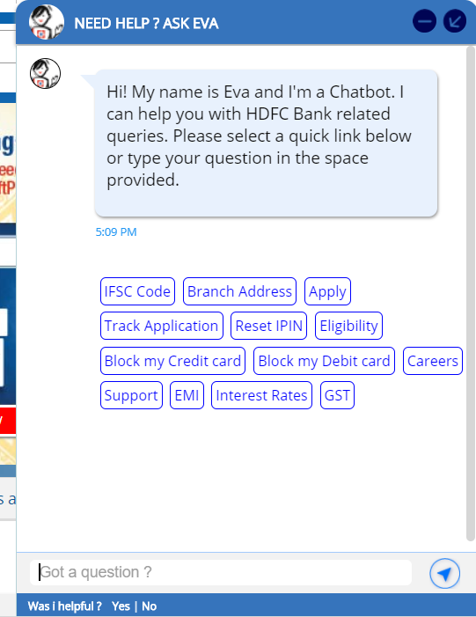

*Figure a. A.I Chat Bot (Simple Reflex Agent)*

A study on Google Blogger, a tool that is available for designing a website.

The following figure shows how to design a website using Blogger

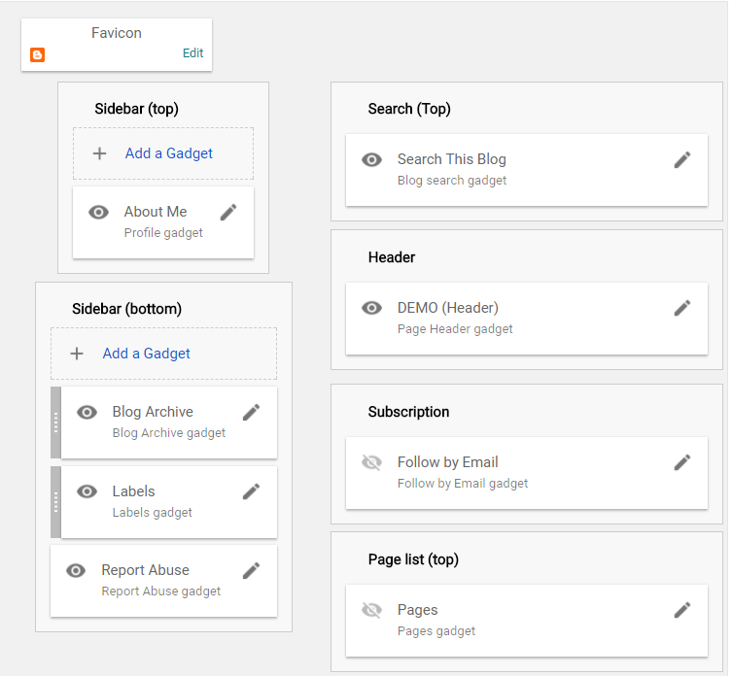

*Figure b. Google Blogger*

# **Requirement Analysis**

**3.1 Functional Requirements**

3.1.1 User Text (in English) Processing

It should tokenize the text and be able to associate the words in the text with its part of speech correctly so as to allow correct classification of the input text. This will further be used for decision making.

3.1.2 Text Classification

The system should be able to choose correct class label for the given text. Example - The system should correctly classify *Game* as video games or indoor or outdoor games. In short this will basically deal with searching appropriate template depending upon user context.

3.1.3 Template Availability

The system should able to search for an appropriate template depending upon the user request and it should satisfy users need.

3.1.4 File System Database

Templates will be stored using File System Methodology and it must be periodically updated as well.

## **3.2 Non Functional Requirements**

3.2.1 Simple UI

The system has a very simple UI especially considering that not everybody is an Developer or Engineer. So that any layman with basic knowledge of English language can able to make use of the system.

3.2.2 Performance

System should be well optimized to exhibit high performance.

3.2.3 Dependencies

The entire system should be put together as a whole package and should work without requiring any additional dependencies.

3.2.4 Functionality

System should be capable of running on machines with both low and high configuration.

# **Project Design**

Our project may be divided into various stages in the following order

* Chat Bot Design: Pattern Matching, Algorithms, ANN, DB
* Using NLP
* Template Location
* Displaying and Storing the template

The techniques will be implemented in the above stages which are explained below

## **4.1 Chat Bot Design**

Chat Bot may look like a normal app. There will be an application layer, a database and APIs to call external services. Chatbots are easy to use by users. There is a general worry that the bot can’t understand the intent of the customer. The bots will be first trained with the actual data. These data will be stored as logs which are used to analyse what the user are trying to convey and what does that mean. With the combination of Pattern Matching, Learning Algorithm’s and Artificial Neural Network(ANN) the bot is implemented. Bot tries to answer with the best suitable answer. For example, if a user is asking “I want to make a Sport’s website.” Or “Create a Sport’s website for me” they both mean the same that user needs a Sport website. Efforts will be made in training the models so that the chatbot should able to connect both of those questions to correct intent and as an output produces the correct answer. If there is no extensive data available, different APIs data can be used to train the chatbot.

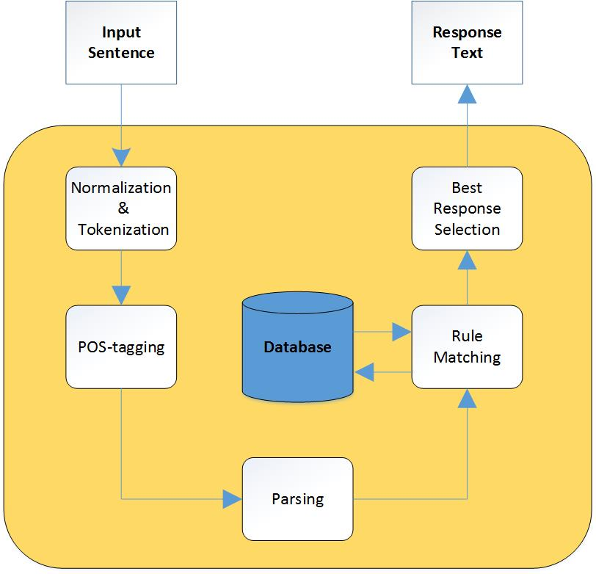

*Figure 4.1 Chat Bot Architecture*

## **4.1.1 Pattern Matching**

Bots will use pattern matching to classify text and produce a suitable response for customers. A standard structure of these patterns is the artificial intelligence markup language (AIML).

Here's a simple pattern matching example:

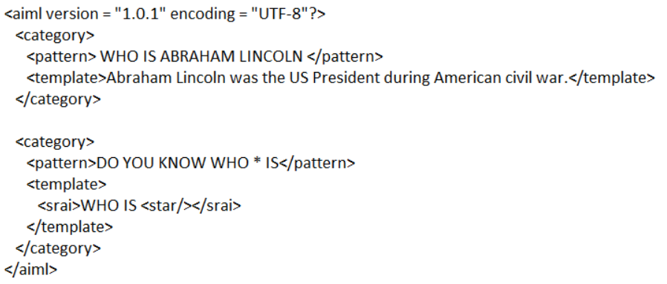

*Figure 4.1.1.1 Pattern Matching Example*

The machine then gives the output:

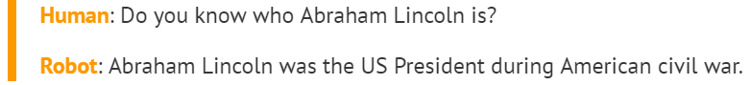

Chatbot knows the answer only because his or her name is in the associated pattern. Similarly, chatbots respond to anything relating it to the associated patterns. But it cannot go beyond the associated pattern. To take it to an advanced level, learning algorithms are used.

## **4.1.2 Algorithms**

Natural Language Processing (NLP) refers to AI method of communicating with an intelligent system’s using a natural language such as English. For an instance, let’s assume a set of sentences are given which are belonging to a particular class. With new input sentence, each word is counted for its occurrence and is accounted for its commonality and each class is assigned a score. The highest scored class is the most likely to be associated with the input sentence.

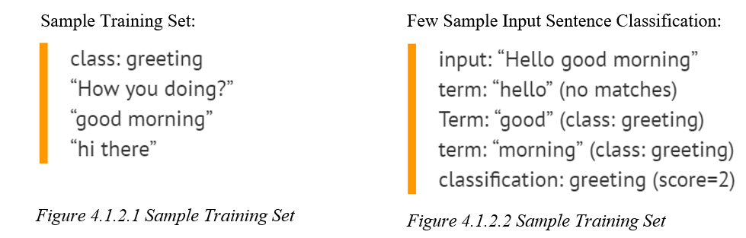

At present it is assumed that the dataset will consist of most of the term. As the bot is put to use in practical environment it may try to infer and learn from the environment.

With the help of equation, word matching are done for given some sample sentences for each class. Classification score identifies the class with the highest term matches but it also has some limitations. The score signifies which intent is most likely to the sentence but does not guarantee it is the perfect match. Highest score only provides the relativity base.

## **4.1.3 Artificial Neural Network**

Neural networks are a way of calculating the output from the input using weighted connections calculated from repeated iterations while training the data. Each step through the training data amends the weights, resulting in an accurate output.

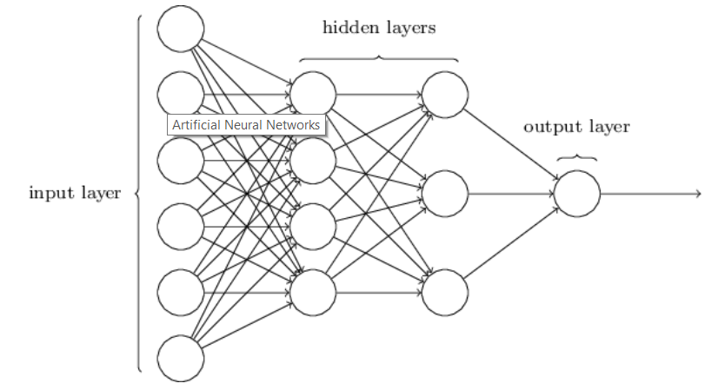

*Figure 4.1.3.1 Artificial Neural Network*

Each sentence is broken down into different words and each word is then used as input for the neural networks. The weighted connections are then calculated by different iterations through the training data thousands of times, each time improving the weights to make it more accurate. The trained data of the neural network is a comparable algorithm of code. When there is a comparably small sample, i.e. in which the training sentences have 200 different words and 20 classes, then that would be a matrix of 200×20. But this matrix size increases by n times gradually and can cause a huge number of errors. In this kind of situation, processing speed should be considerably high.

## **4.1.4 Link to Database**

Chatbot will be connected to database. Chatbot databases will be used to feed the chatbot information needed to give a suitable response to the user. Data about user activities and whether your chatbot was able to match their questions is captured in the datastore. NLP translates human language into information with a combination of patterns and text that can be mapped in real-time to find applicable responses.

## **4.2 Using the NLP**

After defining objective, target audience and context, it may be found that chatbot has some sort of artificial intelligence and that can react to the user queries, to their requests and actions, and assist them. In order to have a better understanding of answers and of free speech, NLP is the tool that helps in finding entities (and/or intents) in a sentence by using some machine learning and syntax/semantic analysis. The more it is fed with contents, more accurate it becomes. As it is a business focussed chatter bot that is been used it should be able to add a new page, or change some user’s information. It would understand the intent (create a new page) and the entity (for example a contact page).

With NLP, the process functions like this:

1. A user types in a message.
2. Look for intents and/or entities
3. Eventually complete the context with a new information
4. Then look for possible responses from the chatbot depending on the intent or the state of the conversation
5. With this pool of responses, select the best one given the user’s context, and reply to the user with the best response.

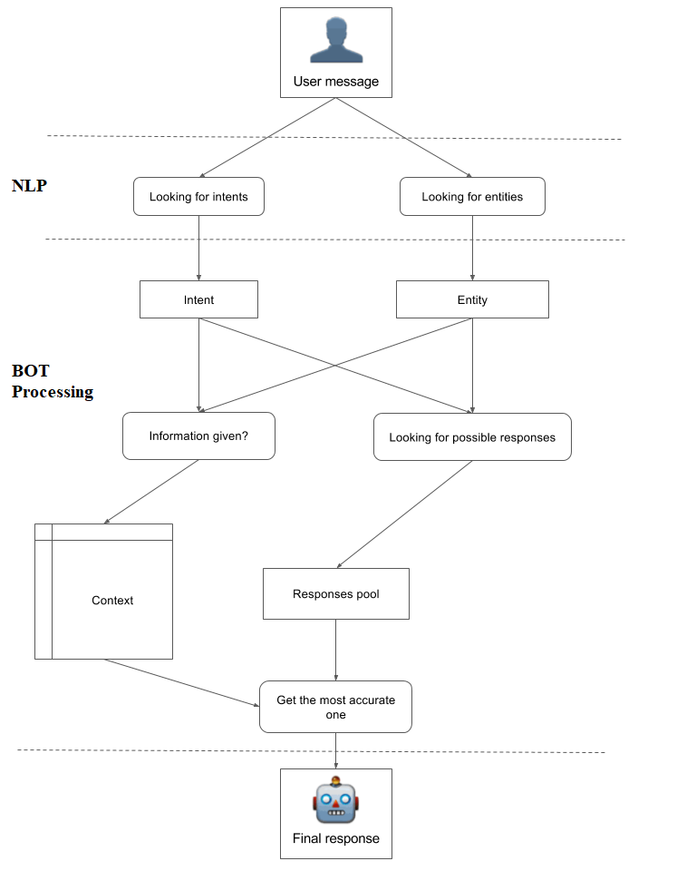

*Figure 4.2.1 Illustration of Internal working*

## **4.3 Storing the Template**

Templates will be stored using file system and are installed onto user’s system during the application installation procedure, user will be asked upon to specify the default storage location for storing the application content, templates, user data, etc.

## **4.4 Displaying the Template**

As discussed earlier the template will be searched by the bot depending upon the user query. The application will have an inbuilt browser feature on which the template will be displayed. The UI of the browser is not at all complex, it will be like normal day-to-day browser used by the people for surfing through the Internet. As the development progresses more pages will be added on to the user project. User can stop the development whenever he/she wishes to abort. The developed website can then be stored on user’s secondary storage. User can also preview the website with any web browser available on user system or he/she can use the inbuilt web browser application.

I/P

O/P

User

File Sys DB

GUI

Internal Process

String

*Figure 4.4.1 An abstract working model*

# **Technologies Used**

# **5.1 Visual C#**

C# (pronounced "C sharp") is a programming language that is designed for building a variety of applications that run on the .NET Framework. C# is simple, powerful, type-safe, and object-oriented. The many innovations in C# enable rapid application development while retaining the expressiveness and elegance of C-style languages.

Visual C# is an implementation of the C# language by Microsoft. Visual Studio supports Visual C# with a full-featured code editor, compiler, project templates, designers, code wizards, a powerful and easy-to-use debugger, and other tools. The .NET Framework class library provides access to many operating system services and other useful, well-designed classes that speed up the development cycle significantly.

## **5.2 PHP**

PHP is a server-side scripting language designed primarily for web development but also used as a general-purpose programming language. Originally created by Rasmus Lerdorf in 1994, the PHP reference implementation is now produced by The PHP Development Team. PHP originally stood for Personal Home Page, but it now stands for the recursive acronym PHP: Hypertext Pre-processor. PHP code may be embedded into HTML or HTML5 mark up, or it can be used in combination with various web template systems, web content management systems and web frameworks. PHP code is usually processed by a PHP interpreter implemented as a module in the web server or as a Common Gateway Interface (CGI) executable.

## **5.3 HTML/CSS**

Hypertext Markup Language (HTML) is the standard mark up language for creating web pages describes the structure of a web page semantically and originally included cues for the appearance of the document.

Cascading Style Sheets (CSS) is a style sheet language used for describing the presentation of a document written in a mark up language.[1] Although most often used to set the visual style of web pages and user interfaces written in HTML and XHTML, the language can be applied to any XML document, including plain XML, SVG and XUL, and is applicable to rendering in speech, or on other media.

## **5.4 MySql**

MySQL is an open-source relational database management system (RDBMS). Its name is a combination of "My", the name of co-founder Michael Widenius's daughter, and "SQL", the abbreviation for Structured Query Language. The MySQL development project has made its source code available under the terms of the GNU General Public License, as well as under a variety of proprietary agreements. MySQL was owned and sponsored by a single for-profit firm, the Swedish company MySQL AB, now owned by Oracle Corporation. For proprietary use, several paid editions are available, and offer additional functionality.

## **5.5 LUIS**

An LUIS is Microsoft Toolkit that helps in implementing one of the concept of A.I that is, Natural Language Processing using Machine Learning. It is especially used for designing chat bots that can response effectively, rather than a simple reflex A.I bot. It has different parameters like utterance, intent and entities which it uses to learn and respond to user queries. What makes it unique is its Active Learning Program. If doesn’t recognise the intent of the user, it will put that query into suggested utterance area from where the programmer can label this new intent. LUIS needs only few intents to start working and also has predefined dataset available to use, like date-time and integer entities. Using the initially defined intents and entities, it can be trained and becomes more responsive to different forms of queries related to the trained set, and help to better classify the intent from the query using probability of the intent specified by the query.

**CONCLUSION**

## **6.1 Conclusion**

We have discussed that usage of website designer bot can simply aid the non-technical user to build their own web site. We highlighted how natural language processing can be used to prepare the website of user choice on the basis of user’s demand or idea. We have described different tools and technologies that can be used to develop simple website by just communicating with the bot. We have also shown an approach to build a system using the above shown technologies.

# **REFERENCES**

1. “Seven golden rules for World Wide Web page design.” Mary L. R. Jones
2. “AI BASED CHATBOT”, Nikita Hatwar, Ashwini Patil, Diksha Gondane
3. “Using lexical chains for keyword extraction”, Gonenc Ercan, Ilyas Cicekli
4. “Chatbot Using A Knowledge in Database.” Human-to-Machine Conversation Modeling. Bayu Setiaji, Ferry Wahyu Wibowo
5. “NATURAL LANGUAGE PROCESSING”, Julia Hirschberg, Bruce W. Ballard, and Donald Hindle
6. “Natural Language to Database Interface”, Jadhav Sneha, Raut Shubhangi, A.S.Zore